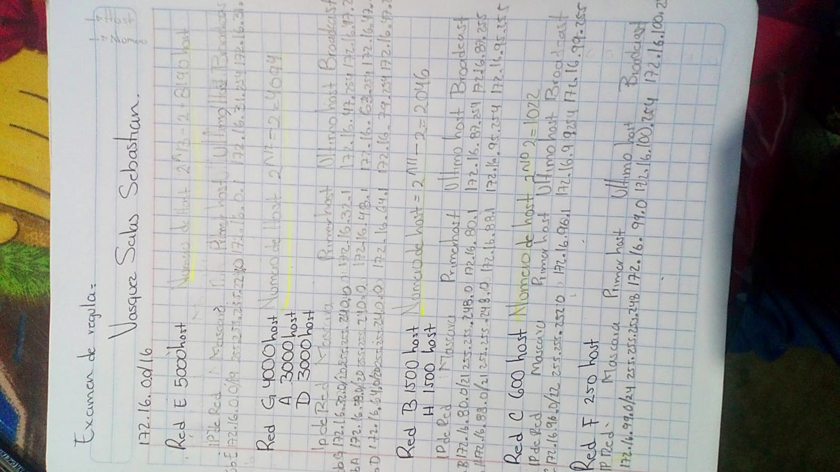

|  |  |  |  |  |
| --- | --- | --- | --- | --- |
| Ip de red | mascara | Primer host | Ultimo host | Broadcast |
|  |  |  |  |  |